**IGME 309 Exercise 01:** **Hi-Lo Guessing Game**

**Due Date:** 09/01, 2025, 11:59pm.

**Objective:**

Your task is to practice in JavaScript programming by creating a Hi-Lo guessing game with numbers.

**Game Description:**

1. The program will initially produce a random number ranging from 1 to 100, both endpoints included.
2. On each of the player's guesses, the program will notify the user whether:
   * Their guess is correct.
   * Their guess is low.
   * Their guess is high.

**Implementation Requirements:**

You are provided with a code template named **‘E01-Template.zip’**. Your task is to complete the JavaScript program in the <script> tag.

**Additional Resources:**

The instructor has provided the following screenshots for this assignment to serve as a reference.

*\* The generated random number is 86.*

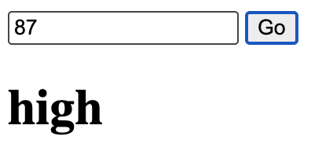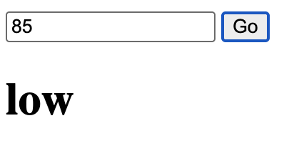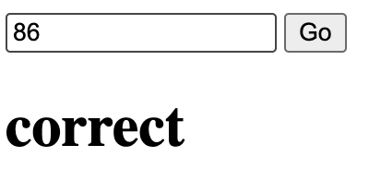

**Submission Rules:**

1. Zip the original source code (original.html), improved source code (improved.html), and the learning report (report.md) into a single archive and submit it to MyCourses.
2. Name the submitted file with your name, e.g. E01-John-Smith.

Some questions to think about when improving your code and writing your learning report:

* If you did anything incorrectly, what went wrong? How did you fix it (them)?
* Does your implementation cover all possible situations?
* Are there any other ways to implement the same function?
* Is there any API that you would like to know more?
* …

* Using AI to improve the code is only recommended, not enforced.

**Rubric:**

|  |  |
| --- | --- |
| **Items** | Points |
| Random number generation. | 30 |
| Read and parse user inputs. | 30 |
| Check user inputs and display results. | 30 |
| Good formatting, clean code style, necessary comments. | 10 |